**DESIGN DOCUMENT FOR HSS-CAM**

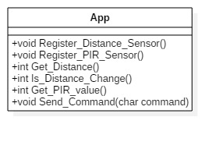

Figure 1 Arduino diagram

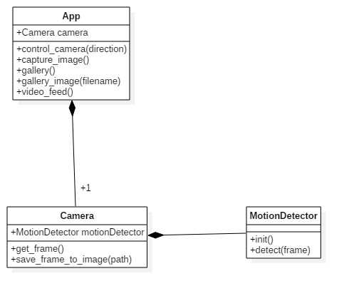

Figure 2 Server Diagram

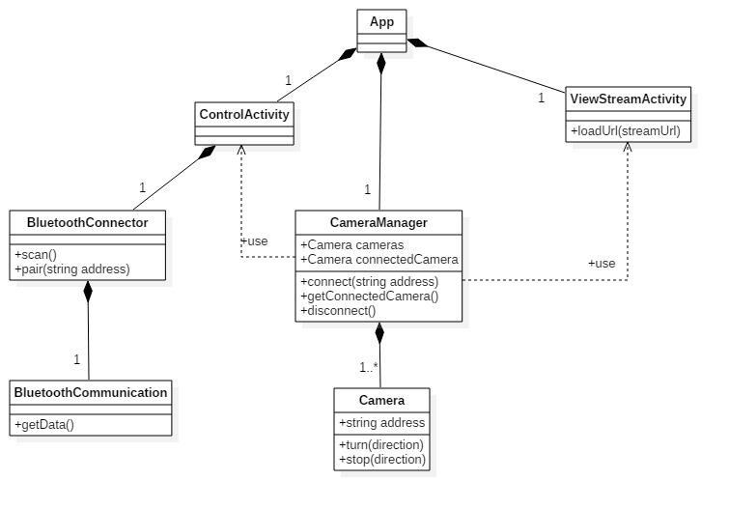

Figure 3 Android app diagram

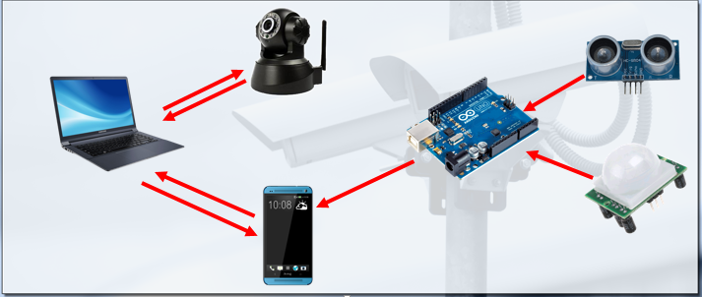

Figure 4 The Hss-Cam System